**BRANCHIING STRATEGY AND WORKFLOW**

|  |  |
| --- | --- |
| Author | PIRZADA NAWAZ SHARIEF |
| Version | 1.0 |
| Reviewed By | Satish |

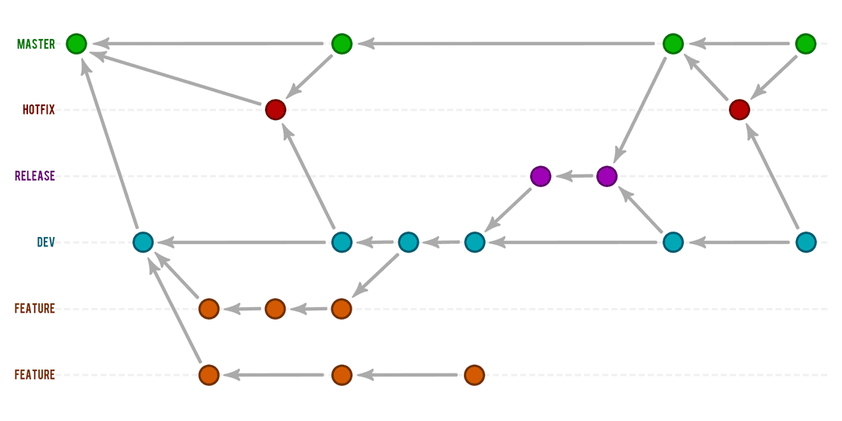

The above Branching Strategy is the Standard followed all over for Continuous Delivery.

1. The Central Repo will contain only two main branches with infinite life time at its core i.e. MASTER and DEV. The MASTER will be the branch with the current production code. Code check-in in this branch is always restricted. The only thing master branch will do is pull the code from the RELEASE branch post successful production deployment and testing.
2. DEV branch will always be pulled from the master branch for every release. Generally DEV and MASTER branches remain in sync immediately post release. DEV branch is also called the integration branch. Code check-in can be done in this branch. This branch is the working branch where all the code for the next release will go either directly or indirectly via code merges from feature branches.
3. HOTFIX Branch: This branch is non-permanent branch where an immediate fix is required on production. This branch is cut-out from MASTER branch and merged back into MASTER and DEV branches post successful release.
4. FEATURE BRANCHES: These branches are used when developing a big new feature that requires a record of changes done to be maintained separately. Also used so that one developer does not impact the work of the other developers or the team. Feature branches are ultimately merged back into the DEV branch from where they are originally cut-from. There are two types of FEATURE BRANCHES, one for the current release and the other for the future releases where the branch may be ultimately abandoned and deleted or merged into DEV.
5. RELEASE BRANCH: This branch will be released to the UAT/Production. This branch will be created from the DEV branch when the code will be ready to be released. This branch is also responsible for bug fixing. Post successful production release from this branch, code from this branch will be merged into DEV and MASTER branches. A separate RELEASE branch exists for every Release with version (e.g. release/copad_v1.0.0). This also makes sure that we have the code back-up of every release.

|  |  |  |
| --- | --- | --- |
| BRANCH TYPE | AGE | BRANCHES |
| PERMANANT | LIFETIME | MASTER,DEV |
| NON-PERMANANT | DELETED WITH TIME | HOTFIX,FEATURE,RELEASE |

|  |  |
| --- | --- |
| **BRANCH** | **NAMING** |
| MASTER | master |
| DEV | Development or develop |
| HOTFIXES | hotfix/[description]_[Jira_Item] |
| FEATURE | feature/[description]_[Jira_Item] |
| RELEASE | release/[ApplicationName]_v[version no] |